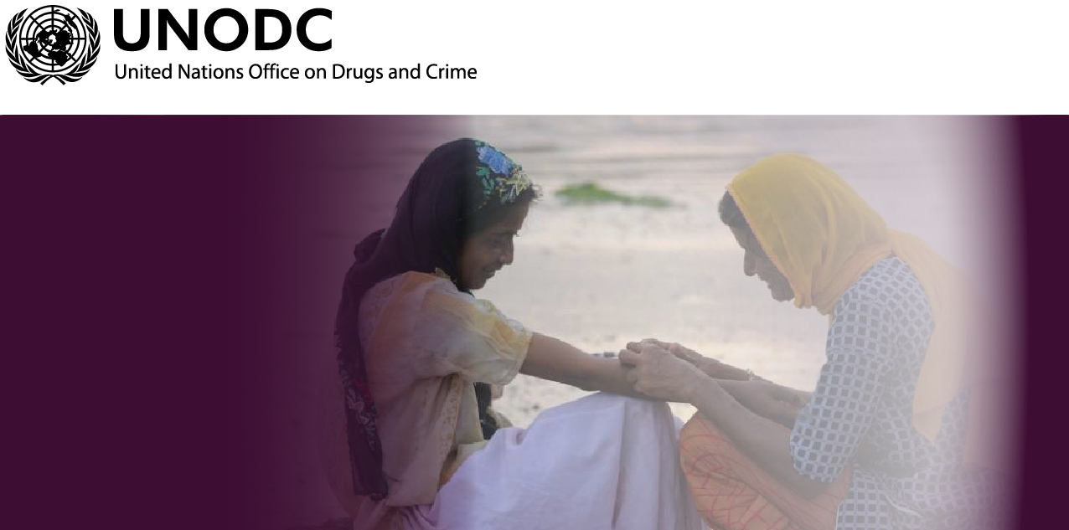

POLICY DIALOGUE

WELCOME, INTRODUCTIONS AND OVERVIEW
15 minutes

Aim:
To set the scene for the policy dialogue and manage expectations.

Learning Objectives:
To increase participants understanding of the value of the addressing the needs of women who use drugs from their perspectives

Expected Outcomes:
Participants understand why the WUD policy brief and technical guide were developed and their potential role to improve HIV and HCV programmes and policy for women who inject drugs.

Materials needed:
Attendance register
Name tags (optional)
Projector and slide sets

Welcome and administration (5 minutes)
Welcome participants to the policy dialogue
Introduce yourself and provide some background that is relevant
Tell people where the bathrooms are and where catering will be provided
Request that people complete an attendance form
Ask each person to introduce themselves

Go through the objectives of the dialogue
- To highlight global and country commitment to expand access to women who inject drugs to HIV and HVC services through appropriate gender-sensitive and gender-specific interventions.
- To introduce policy/decision makers, service providers, community representatives and others to the WUD policy brief and technical guide
- To provide an opportunity to knowledge sharing and engagement around increased support for and provision of recommended HIV and HCV services addressing the needs of women who use drugs
- To provide a networking opportunity

Briefly go through the agenda

 |  | Dialogue with policy makers
Start | End | Session
9:00 | 9:30 | Welcome, introductions & overview of the WUD policy brief and technical guide
9:30 | 10:00 | Overview of local policy context
10:00 | 10:30 | Overview of existing HIV and HCV services addressing the needs of women who inject drugs
10:30 | 10:45 | Break
10:45 | 12:30 | Facilitated dialogue: challenges and solutions to enhancing HIV and HCV policy and programmes
12:30 | 12:55 | The way forward
12:55 | 13:00 | Closing and thanks
Background and rationale (5 minutes)

In September 2015, United Nations member states adopted the 2030 Agenda for Sustainable Development. The Goal 3 is: Ensure healthy lives and promote well-being for all at all ages. The target 3.3 is: “By 2030, end the epidemics of AIDS, tuberculosis, malaria and neglected tropical diseases and combat hepatitis, water-borne diseases and other communicable diseases”

The UNAIDS Fast-Track strategy is aligned with the SDGs and emphasizes a five-year window (2016–2021) for rapid acceleration of HIV treatment and prevention services, to end AIDS by 2030. The Fast-Track strategy was adopted by the United Nations Political Declaration on AIDS 2016, in which member states committed to encouraging those member states with high HIV incidence to “take all appropriate steps to ensure that 90% of those at risk of HIV infection are reached by comprehensive prevention services.”

The UN General Assembly held a Special Session (UNGASS) on drugs in 2016. This Special Session was an important milestone in achieving the goals set in the policy document of 2009 "Political Declaration and Plan of Action on International Cooperation towards an Integrated and Balanced Strategy to Counter the World Drug Problem", which defined action to be taken by Member States as well as goals to be achieved by 2019. The outcome document of the 2016 UNGASS reiterates commitments to the SDGs and calls for a health oriented, gender sensitive, human-rights based response to the world drug problem.

Overview of the WUD policy brief and technical guide and training (15 minutes)

The WUD policy brief and technical guide are built on the comprehensive package of nine interventions for HIV among people who inject drugs, also called the harm reduction package, which is detailed in the 2012 edition of the WHO, UNODC, UNAIDS Technical Guide for Countries to Set Targets for Universal Access to HIV Prevention, Treatment and Care for Injecting Drug Users and in the WHO Consolidated Guidelines on HIV prevention, Diagnosis, Treatment and Care for Key Populations, from 2014.

The development of the policy brief and technical guide on services addressing the specific HIV-related needs of women who inject drugs was overseen by a working group, formed in 2013, which included representatives from the International Network of Women Who Use Drugs (INWUD), the Women’s Harm Reduction International Network (WHRIN), and the Eurasian Harm Reduction Network (EHRN). Collectively, the two documents provide up-to-date information on key issues concerning HIV prevention, treatment and care related to women who inject drugs.

UNODC published the policy brief in July 2014, together with the International Network of People Who Use Drugs (INPUD), INWUD, WHO, UN Women and UNAIDS, and the practical guide in 2016.
Basic principles:
HIV and HVC services for women who use drugs, are most effective when offered on a voluntary basis in an enabling environment created by supportive policies and strategies. It is beneficial to seek to ensure that services:
- are physically accessible, affordable, equitable, non-judgemental, non-discriminatory and unrationed; and
- are not restricted by socio-demographic or other criteria such as sex/gender, employment status and profession (including sex work), criminal justice history (including imprisonment), substance use status, or pregnancy status.

Moreover, it is recommended that all harm reduction services be governed by the following core principles:
- Gender mainstreaming – based on the recognition that gender equality and equity are linked to human rights, fairness and social justice for women and men
- Non-discrimination – treating all clients fairly regardless of age, sex, sexual orientation, gender identity, ethnicity, religion, class, occupation and drug use status
- Informed choice and consent without coercion – through providing a full range of information and options to enable clients to make well-considered, voluntary decisions and respecting their autonomy in doing so
- Confidentiality – respecting and safeguarding the privacy and autonomy of clients
- Respect – treating each client with respect and dignity
- Access for all – services are relevant to as many clients as possible, with respect to availability, affordability and acceptability
- Working in partnership with government, civil society and all social sectors, both public and private
- Build and sustain comprehensive services – linking HIV prevention, treatment and care services, reproductive and sexual health, as well as other related health services needed by clients
- Promote, respect and enforce the human rights of clients, including the right to adequate health information and reproductive rights
- Accountability of all staff, including service managers, for the achievement of gender-related goals and objectives
- Empower individuals and communities through outreach and community education about HIV and associated gender inequalities
- Meaningful participation of people who use drugs, including WID, in all aspects of the design, planning and delivery of harm reduction services—including involvement as decision makers, experts and implementers. Participation can be supported through peer-based skills development and capacity-building

LOCAL POLICY CONTEXT
30 minutes

Aim:
To provide an overview of relevant policy and policy reform around drug use, HIV and related conditions.

Expected Outcomes:
Participants understand the policy context, including recent and planned developments.

Materials needed:
Projector and slide set

Slides: Presentations from policy/decision makers

The facilitators should introduce each policy/decision maker and allow them to give their presentation. Request participants to note down their questions and keep them for the interactive dialogue session that will follow.

FACILITATORS’ NOTES
- Request recent biographies of the policy/decision makers that will participate so that these can be read as they are introduced.
- Request policy/decision makers to cover latest policies and practice guidance related to health care, education and social services for people who inject drugs in the country with a specific focus on women. Request that they also note any future plans in their presentation.
- Aim to limit the time of presentations by: (1) providing accurate guidance to policy/decision makers on what to prepare; (2) confirm their allocated time on the agenda; (3) restrict the session to 30 minutes, and (4) use a time keeper and time cards.

OVERVIEW OF LOCAL HIV AND HCV PROGRAMMING FOR WOMEN WHO INJECT DRUGS
30 minutes

Aim:
To provide an overview of ongoing HIV and HCV services addressing the needs of for women who inject drugs

Expected Outcomes:
To become aware of existing and planned services addressing the needs of for women who inject drugs and the challenges they face in scaling-up access.

Materials needed:
Projector and slide set

Slides: Presentations from 2 presenting organizations
The facilitators should introduce each speaker. Request participants to note down their questions and keep them for the interactive dialogue session that will follow.

FACILITATORS’ NOTES
- Request recent biographies of the people that will participate so that these can be read as they are introduced.
- Use a time keeper and time cards.
FACILITATED DIALOGUE
105 minutes

Aim:
To provide an opportunity to discuss challenges, concerns and issues

Expected Outcomes:
Participants be able to engage around priority issues, with different perspectives being raised.

Materials needed:
Microphone(s)
Note taker

The facilitator should be mindful of the engagement and guide discussions and implement risk mitigation strategies to keep engagement positive.

FACILITATORS’ NOTES
- Aim to get a range of questions from people from different parts of the room, and different genders, socio-economic and geographic perspectives etc.
- Monitor the time to allow for discussion around solutions and next steps.

THE WAY FORWARD

30 minutes

Aim:
To provide an opportunity to discuss next steps for further engagement

Expected Outcomes:
To identify actions for the short, medium and long term

Materials needed:
Microphone(s)
Note taker

https://sustainabledevelopment.un.org/
http://www.unaids.org/sites/default/files/media_asset/20151027_UNAIDS_PCB37_15_18_EN_rev1.pdf
https://www.unodc.org/documents/postungass2016/outcome/V1603301-E.pdf
http://www.unodc.org/documents/hiv-aids/publications/WOMEN_POLICY_BRIEF2014.pdf
http://www.unodc.org/documents/hiv-aids/2016/Addressing_the_specific_needs_of_women_who_inject_drugs_Practical_guide_for_service_providers_on_gender-responsive_HIV_services.pdf
For the purposes of this guide, harm reduction is defined by the nine interventions of the 'comprehensive package' of services as detailed in the WHO, UNODC, UNAIDS Technical Guide for Countries to Set Targets for Universal Access to HIV Prevention, Treatment and Care for Injecting Drug Users.
WHO, UNODC, UNAIDS. Technical Guide for Countries to Set Targets for Universal Access to HIV Prevention, Treatment and Care for Injecting Drug Users. 2012 revision
WHO. Consolidated Guidelines on HIV prevention, Diagnosis, Treatment and Care for Key Populations. 2014
UNODC, INPUD, UN Women, UNAIDS, WHO. Women Who Inject Drugs and HIV: Addressing Specific Needs. Policy brief. 2014

