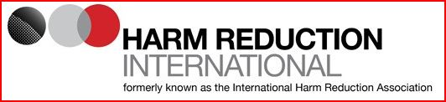
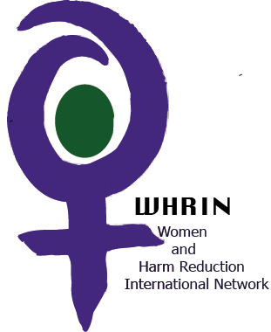
HRI/WHRIN survey
The Women and Harm Reduction Network (WHRIN) in collaboration with Harm Reduction International (HRI), is posting this survey in order to both inform a strong women’s element in the HRI Global State report and to capture information of value in tailoring WHRIN advocacy efforts.
Background on the Harm Reduction International Global State survey:
The Global State of Harm Reduction 2018 is the sixth report in the GSHR series. As in past editions, it will consist of a global overview and nine regional chapters, which will provide an update of key developments in harm reduction since the last GSHR report was released in 2016. The report is the result of collaboration between Harm Reduction International and harm reduction networks, researchers, and organisations of people who use drugs, whose input is essential to reflect the situation around the world.
We have adapted the much broader Global State survey to focus on particular issues relating to women and harm reduction, while trying to keep the survey as brief and user friendly as possible. More information on the original survey can be found here.
We really appreciate your time in completing this survey. It is not expected that all respondents will have information/answers for all 20 questions. Please do not be deterred and contribute instead as best you can.
Where possible, please include specific cases or anecdotes (and provide references where available). If your answers relate to a specific country within a region, please state in the text box below.
Country or region:

Harm Reduction Developments since 2016
Harm Reduction Responses
Regional overview
- What have been the major developments in harm reduction implementation for women who use drugs in your country or region since 2016?
Please cover the following in your answer:
a) Have any countries/territories newly introduced harm reduction services for women who use drugs, rapidly scaled up existing services or have concrete plans to do so?
b) Have any countries/territories seen a scale back or closure of existing harm reduction programmes for women? If yes, please comment on the official reasons for programme closure and scale back.
c) Have there been changes to the way in which harm reduction services for women are delivered and who delivers them in any countries/territories? (e.g. the state, NGOs with or without state support, government and NGOs, international implementing agencies, etc.)
d) Have new regional or sub-regional groups, networks or initiatives been formed, or meetings been held since 2016 that have been important for harm reduction services for women?
e) Have barriers to accessing services for women who use drugs increased or lessened in any countries?
(Please add references, case examples or anecdotes as available)
(Please expand the text box accordingly)

Advocacy, civil society and drug user networking
- Have there been advocacy campaigns for women who use drugs over the past 2 years that harm reduction organisations or drug user groups have led on or have been part of that should be mentioned?
- Does your country have a national harm reduction network? If yes, is this attached to a broader regional harm reduction network? Does it include a focus on women
- Does your country have a national drug user network? If yes, is this attached to a broader regional drug user network?
- Does your country have a network or subnetwork for women who use drugs? If yes, is this attached to a broader regional drug user network? Please provide details below.
- Are there mechanisms in place (at country or local level) designed specifically to assist women who use drugs to access justice and existing social services (for example legal empowerment programmes, violence prevention and/or supportive reporting programmes, violence shelters, alternatives to incarceration, community housing … specifically inclusive of or specifically targeting women who use drugs?
- Have there been any major conferences or other high-level events on women and harm reduction at a national or regional level during the past two years?
(Please add references, case examples or anecdotes as available)
(Please expand the text box accordingly)

Policy
- Please note any policies you know of that specifically affect women who use drugs.
- Have there been any policy or practice changes impacting on women who use drugs – with regard to eg sentencing, child custody, in relation to pregnant women who use drugs, compulsory treatment …?
(Please add references, case examples or anecdotes as available)
(Please expand the text box accordingly)

Funding
- Have there been major developments in terms of funding for harm reduction services for women (implementation and advocacy) since 2016? If yes, please describe. If no, what finding does exist if any?
(Please expand the text box accordingly)

Harm reduction services
- Do women experience more barriers to accessing NSPs,? If so, are there targeted efforts to reach them with services?
- Do women experience more barriers to accessing OST (opioid substitution therapy)? If so, are there targeted efforts to reach them?
- Are OST services integrated with other health services for women such as prenatal services?
- (If applicable), do women experience more barriers to accessing drug consumption rooms? If so, are there targeted efforts to reach them?
(Please add references, case examples or anecdotes as available)
(Please expand the text box accordingly)

Harm reductions in prisons
- Are the harm reduction services available in mens prisons (as so far provided – eg OST, HIV testing, ART, NSP, HCV testing and treatment, TB testing and treatment, naloxone) also available in women’s prisons?
(Please add references, case examples or anecdotes as available)
(Please expand the text box accordingly)

Access to HIV testing and treatment
- What are the main barriers to HIV testing for women who use drugs in your country or region?
- How accessible is ART for women who inject drugs in your country or region?

(Please add references, case examples or anecdotes as available)
(Please expand the text box accordingly)

Access to HCV and TB testing and treatment
- What are the main barriers to hepatitis C treatment for women who use drugs in your country or region?
- What are the main barriers to TB diagnosis and treatment for women who use drugs in your country or region?
(Please add references, case examples or anecdotes as available)
(Please expand the text box accordingly)

- What would you say are the top three issues of concern for women who use drugs in your country/region? Please number the most important ‘1’ through to 3.

Stigma
Violence (partner and/or State)
Child custody – community and state
Sexual and reproductive health service access
Criminalisation
Lack of women-specific harm reduction services
Other (please specify)

(Please add references, case examples or anecdotes as available)
(Please expand the text box accordingly)
1.
2.
3.
Comments:

Your help with this survey will form part of the Global State of Harm Reduction 2018 and used to inform WHRIN advocacy and is invaluable. Thank you kindly for all your help and insight.
Please post your completed survey form to: rlbirgin@yahoo.com.au by Friday May 25, 2018.

